# **Fix Slow SSH Access**

**Steps To Fix Slow SSH Access:**

**Edit resolv.conf (Method 1):**

1. Access Linux server.
2. Go to folder /etc/.

|  |
| --- |
| cd /etc/ |

1. Edit resolv.conf.



|  |
| --- |
| vi resolv.conf |

1. Remove everything except # Generated by NetworkManager line.

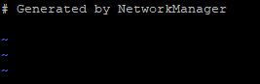

1. Save.
2. Reboot server.
3. Retry access.

**Edit sshd_config (Method 2):**

1. Access Linux server.



1. Go to folder /etc/.

|  |
| --- |
| cd /etc/ |

1. Go to folder /ssh/.

|  |
| --- |
| cd ssh |

1. Edit sshd_config.

|  |
| --- |
| vi sshd_config |

1. Search UseDNS line and change from yes to no.



1. Reboot server.
2. Retry access.